Fire detection through Image Processing; A brief overview
Hafiz Suliman Munawarª, Usama Khalid^{b} and Adnan Maqsood^{c}
ªResearch Centre for Modeling & Simulation, NUST Islamabad, Pakistan hafizsuliman91@gmail.com
^{b} CS Department COMSATS Institute of IT, Wah Cantt, Pakistan usama_khalid@hotmail.co.uk
^{c}Research Centre for Modeling & Simulation ,NUST Islamabad, Pakistan adnan@rcms.nust.edu.pk

ABSTRACT
Environmental protection and the reduction of hazards relies on efficient systems for the detection of fire. The fire detection technology relies on detection of smoke. This can further be improved by the use of technology that readily detects the images through the sensitive cameras which can capture the spectral images. An algorithm for the detection of motion can be helpful in detecting fires at the earliest and consequently preventing any damage. The current algorithms rely on the use of MATLAB (Image Processing Toolbox) for the extraction of fire features and detection of motion. The proposed system revolves around a video based detection of fire and smoke. An optical flow for vector extraction is used in this method for training the neural networks. The optical flow vector creations can be used to estimate the amount of motion in an object while its movement from one frame to another. A machine learning based algorithm is used to specify the flame region. The optical flow estimators such as the Optical Mass Transport (OMT) and the Non-Smooth Data (NSD) are used for the detection of fire and the smoke.
Index Terms:
Fire detection, MATLAB, optical flow, OMT, NSD
- INTRODUCTION
Fire detection is very important for the protection of environment and safety of people. The methods of fire detection which are based on the image information are more effective as compared to the other techniques which rely on multisensory wireless networks or the sensor systems. The fire detection can improve the accuracy of the fire alarm, real-time and the robustness. Fire detection technology can be classified into various sub-categories based on different types: (i) The purpose flame or the smoke detection, (ii) The spectral range of the camera used and (iii) The range of the system. Fire and smoke detection is quite challenging, particularly in the case of open environments including the chemical and power plants, as they can have affects on the surrounding areas (Fig No. 1). Smoke is a very good indicator of fire. Therefore, to detect fires at the earliest, the characteristic features of smoke should be considered when extracting information from images. There are different features such as environmental response, shape and the unsteady nature etc used for smoke and colour, texture, rigid motion etc for fire respectively. If the optimal algorithms can be used in each part of motion detecting areas and for the extraction of fire features, the system performance can be developed. Image analysis was

done using the MATLAB (Image Processing Toolbox).
Motion and Texture Features:
In the pattern recognition system, the choice of the feature plays an important role in the performance of classification.
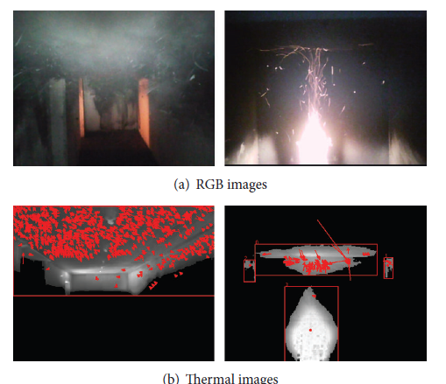
Fig 1: (a) The images showing fire scenes and (b) objects extracted from the thermal images by the optical flow vectors overlaid (Kim et al., 2016).
$$C_{ij }= {P_{ij}}/{\sum_{i,j=1}^{N_{G}}{P_{ij}}} (1)$$
Both the motion and the texture features were selected areas as they were crucial in the previous study on the fire and smoke detection and also best suitable for the thermal image analysis that is the major information the fire fighting robot can acquire under the fire environments. Optical flow, a popular motion measurement, was used for the motion characteristics, while the first and second statistical texture features were applied for the texture measurement.
Motion Features through the Optical Flow:
Optical flow is a helpful tool to recognize motion of an object in the sequential images (1). It consists of local and the global methods. The local strategy is Lucas-Kanade which is quite robust and has a flow field which is less dense. On the other hand, the global method if the Horn-Schunck (HS) strategy which is extremely sensitive to noise and has a dense flow field (2).
Two features of optical flow vector number and the optical flow mean magnitude were computed to quantitatively characterize motions of the fire, smoke, and their reflections. Fig 1 (a) and (b) contains RGB and thermal images of dense smoke in a hallway and a wood crib the fire in a room. Red arrows in the thermal images indicate the direction and magnitude of the optical flow vectors with the red boxes and that show smoke, fire, and thermal reflections.
First and Second Order Statistical Texture Features:
The first-order statistical features estimate individual property of the pixels, not characterizing any of the relationship between neighbouring pixels, and can be computed with the intensity histogram of the candidate region of interest (ROI) in the image. In 2013 Huda et al calculated (3), mean, variance, standard deviation, skewness, and kurtosis whose formulas are equation 2, 3, 4 and 5.
$$MNI= \frac{1}{N_{P}}\sum_{i,j=1}^{N_{P}}{I_{i,j} } (2)$$
$$VAR= \frac{1}{N_{P}}\sum_{i,j=1}^{N_{P}}{{(I_{i,j}-μ)}^{2}} (3)$$
$$STD\left(σ\right)={\left(\frac{1}{N_{P}} \sum_{i,j=1}^{N_{P}}{{\left(I_{i,j}-μ\right)}^{2}}\right)}^{\frac{1}{2}} (4)$$
$$SKE= \frac{1}{σ^{3}N_{P}}\sum_{i.j=1}^{N_{P}}{{(I_{i,j}-μ)}^{3}} (5)$$

Where, MNI stand for mean, VAR for variance, STD for standard deviation, SKE for skewness and KUR for kurtosis respectively, and 𝐼𝑖, refers to the intensity of a pixel at 𝑖 and 𝑗 and 𝑁𝑃 denotes the number of pixels (NOP) of the object in the image.
The second-order statistical features:
It’s represent spatial relationships between a pixel and its neighbours. Grey-level co-occurrence (4) is used to account for the adjacent pixel relationships in four directions (horizontal, vertical, left, and right diagonals) via quantizing the spatial co-occurrence of neighbouring pixels. A total number of seven second order statistics features were used containing dissimilarity, entropy, contrast, inverse variance, correlation, uniformity, and inverse difference moment. To the measure these features, a normalized co-occurrence matrix 𝐶𝑖𝑗 is used which can be defined as:
$DIS= \sum{C_{ij}|i-j|}$ (6)
$ENT= - \sum{C_{ij}\log{C_{ij}}}$ (7)
Where, 𝑃𝑖𝑗 refers to the frequency of the occurrences of the gray level of the adjacent pixels at and within the four directions and denotes the number of the gray-levels in the quantized image. The denominator of (2) normalizes 𝑃𝑖𝑗 to be estimates of the co-occurrence probabilities. After building the normalized co-occurrence matrix 𝐶𝑖𝑗, seven features of the second-order statistics features were computed by following formulas:
$CON= \sum{C_{ij} {\left(i-j\right)}^{2}}$ (8)
$INV= \sum{\frac{C_{ij}}{1+|i-j|}}$ (9)
$COR= \sum{\frac{(ij+ μ_{i}μ_{j}- μ_{i}- μ_{j} C_{ij})}{σ_{i}σ_{j}}}$ (10)
$UNI= \sum{C_{ij}^{2}}$ (11)
$IDM= \sum{\frac{C_{ij}}{1+ {(i-j)}^{2}}}$ (12)
Where, dissimilarity stands for DIS, entropy for ENT, contrast for CON, inverse variance for INV, correlation COR, uniformity UNI, and inverse difference moment for IDM respectively.
Fire Detection Device:
As a rule fire detection devices are separated into two basic types: manually actuated and automatically actuated devices shown its types given below in Fig 2.
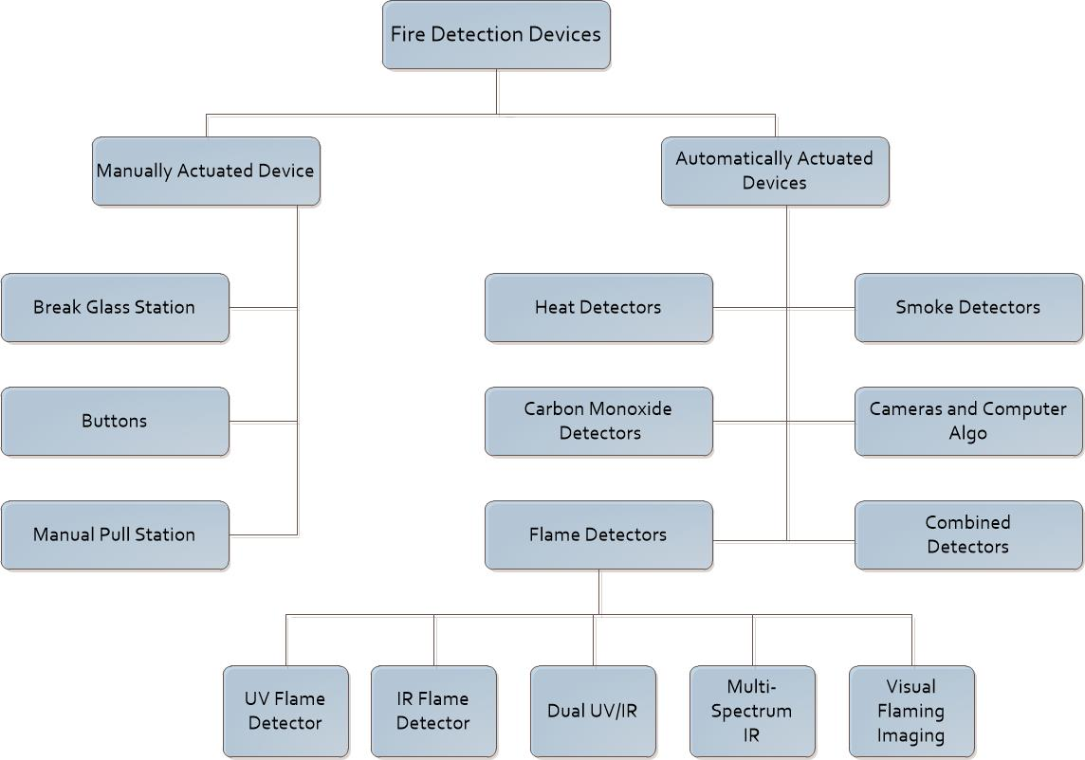
Fig 2. The Fire detection device (Farah et al., 2015).
Manually actuated devices are located close to the exits and in many cases look similar to the red button on the wall. Someone should push the button in the case of a fire risk (5).
Fire detection sensors are classified into smoke sensors, flame sensors, heat sensors, carbon monoxide sensors and also cameras operated via computer algorithms. Point fire detectors have taken sample in that place where they are installed, they are installed in front of each other on the opposite walls of the room and based on laser technologies, and this type of detectors can operate in large spaces up to the 100 meters long. The fire detectors are the class of smoke detectors which can be placed in the ventilation system or another place and it takes the samples of the air at specified predetermined intervals (6). Heat detectors are subtle to the temperature and they can be passive or active, passive ones do not use the energy and when the temperature rises to the vital point, the sensor forms a specific signal the electrical circuit of alarm. Active detectors have use energy sources. They can give information not only when the temperature will rise to a critical point but the alarm also turns on when the temperature rises very fast. Flame detectors detect the infrared and ultraviolet radiation from a flame through the inserted photo detector and they are used in places where fire can starts rapidly without smoke (7). Carbon monoxide detectors are a very important part of fire safety systems in buildings and institutions. The main difficult with carbon mono-oxide is that it does not smell. Carbon monoxide is formed by portable generators, stoves, burning coal and wood (8). Carbon mono-oxide can cause death even if they are not sleeping because people cannot detect the existence of this gas, therefore it is so vital to use carbon monoxide detectors, and there are three basic types of it: metal-oxide-semi-conductor, biometric and electrochemical. There is no need to check batteries with the using the first technology metal-oxide-semi-conductor, for the reason that it is always connected to the house power. Biometric detector has gel-coated disk, it’s becomes dark in the existence of carbon mono-oxide. Alarm on when changing the colour of the disk turns. Electrochemical detectors work for the cause that the chemical reaction with carbon mono-oxide generates electrical current (9). The most part of carbon mono-oxide detectors alarm when carbon mono-oxide concentration quickly increases. There are also detectors which detect the long-term changes of carbon mono-oxide concentration but they are rather expensive. Cameras operated through computer algorithms are used frequently in lofty voluminous spaces or the other places which traditionally are the most challenging for the fire safety (10).
- LITERATURE REVIEW
Fire detection is very critical parameter in many fields of the industrial and forest areas. Several researches and studies are going on the flame and the smoke detection. Some algorithms are developed which used specially for these purposes. These are statistical colour model, spatio- Temporal Flame Modeling and the Dynamic Texture Analysis and at present optical mass flow estimators is getting attention. Now Scientists (11) are focusing on various algorithms and their advantages/disadvantages used in the flame detection as shown in Fig 3.
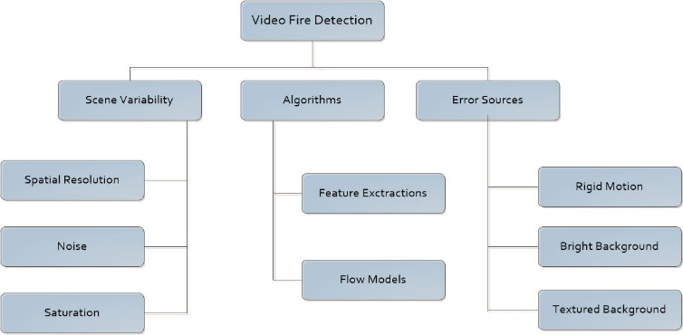
Fig 3: Scope of the fire detection (Dimitropoulos et al., 2016).
Fire Detection Techniques:
In 2013 Bosh et al. (12) proposed a fire detection method based on the multisensory wireless network. This method consists of wireless sensor network with the central monitoring station. Each of sensor has two camera’s (visible and thermal) and a motor with the different settings to sweep and operate a larger area; and an integrated system of capture, processing and the communication. This network allows remote monitoring of each of location as well as communication between each sensor and the control station. In result, it increases coverage area with the faster and the safer response. The sensor scheme allows automatic monitoring of the coverage area as well as the processing, generation and transmission of alarms to other elements in the wireless sensor network and to the control station. With the geographic information system, station can monitor the proper operation of the system and locate the position of each sensor. Each pixel is collected of resolution cell corresponding to the certain coordinates of rank. Pixel-by-pixel processing is finished to generate vectors describing the time history of each resolution cell. The different types of detectors are defined with the importance given to the decision fusion rules for the persistence and the increase detectors, which can gives short and long-term features expected in the fire.
Celik et al. (13) proposed a system based on the real-time flame detector. This system can combine the statistical colour information to the foreground information. Visual fire detection is more useful in an area where standard conventional the fire detectors cannot be used. This algorithm combines the colour information of the flame with the temporal changes in the video sequences. Background modelling is used where the camera’s position is fixed and picture detected is stationary. Initially images are consists of Red, Green and Blue (RGB) components. The Background information is modelled with the uni-model Gaussian method; then Mean and covariance matrix are the extracted from an images which are contains Luminance, Chromared and Chromablue components. Background modelling is collected of three steps: first, Estimation of model parameters and change map. Second, adaptation of the model parameters and third is the permanent change in background.
For colour detection, Water Philips et al (14) uses a lookup table for recognition of the fire in video sequences using a manual training set. The lookup table is the used to identify the possible fire pixels of colour. Colour lookup algorithm used in this system may be containing of following steps: (i) Create pairs of the training images. (ii) Construct the colour histogram, and the (iii) Colour transformation. i.e., the transformation of RGB to Boolean value which indicates the whether an input colour is matches with the colours predicate. The techniques used for matching is point feature matching and the testing was carried out in MATLAB (Image processing toolbox and Computer Vision system toolbox) (15). The first step of the algorithm removes the background information and detects the foreground motion. The second step is the applied if there is detection of the fire-like colour objects in the foreground pixels. These steps are to reject the non-fire objects from the foreground pixels. Third step is used to remove the noise in change detection map. In the fourth step, the blobs are detected using connected component labelling algorithm (16). Celik et al. (17) further enhance system that uses a statistical colour model with Fuzzy logic for fire pixel classification. The proposed system developed into two models; one based up on luminance and the second based on chrominance. Existing historic rules are the replaced with the Fuzzy logic to make the classification more robust and effective. This model achieves up to 99.00% correct the fire detection rate with a 9.50% false alarm rate.
RGB Colour Model:
A fire image can be described through its properties based on colours. These colours properties are extracted into three different elements of colour pixel i.e. R, G and B, which are used in colour detection. RGB colour model is used to detect red colour information in an image. Regarding the RGB values, the inter-relation between the R, G and B colour channels are: R > G and G > B. In the fire colour detection R should be more stressed then the other component, and hence R becomes the domination colour channel in an RGB image for the fire.
This implies that R is under a condition to be above a pre-determined RTH threshold value.
All the conditions pertaining to the colour of fire in any image are summarized as following:
Condition1: R > RTH
Condition2: R > G > B.
Then the result is needed to convert to HSI colour model where H represents hue, S represents saturation and I represent intensity. The conversion can be done using the following formula:
$$H= \{_{360- θ if B >G}^{θ if B ≤G}$$
With
$$θ= \cos^{-1}\left\{\frac{0.5 \left[\left(R-G\right)+\left(R-B\right)\right]}{{\left[{\left(R-G\right)}^{2}+\left(R-G\right)\left(G-B\right)\right]}^{\frac{1}{2}}}\right\} (13)$$
$$S=1- \frac{3}{\left(R+G+B\right)}\left[\min\left(R,G,B\right)\right] (14)$$
$$1= \frac{1}{3}\left(R+G+B\right) (15)$$
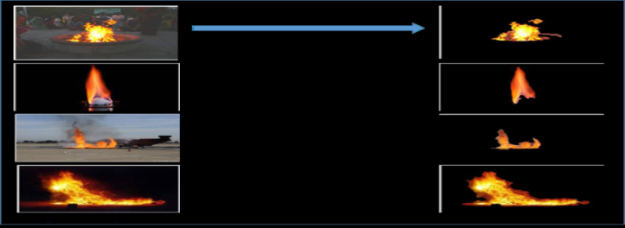
Fig 4: Show the results from the 1st technique (Poobalan et al., 2015).
Where, R, G and B represent the component of Red, Green and Blue within the image as shown in Fig. 4.
Sobel Edge Detection:
Next, the sobel edge detector can be used for detecting the growth of fire as present in the images. This can be done by applying 3x3 masks to the images. Convolution is both commutative and associative and is given as below;
$$∇f ≅\left|\left(z_{7}+ {2z}_{8}+ z_{9}\right)-\left(z_{1}+ {2z}_{2}+ z_{3}\right)\right|+ \left(z_{3}+ {2z}_{6}+ z_{9}\right)-(z_{1}+ {2z}_{4}+ z_{7})$$
The mask which was used in this technique is as given below:
$$M_{x}= \begin{matrix}-1 & -2 & -1 \\ 0 & 0 & 0 \\ 1 & 2 & 1\end{matrix} and M_{y}= \begin{matrix}-1 & 0 & 1 \\ -2 & 0 & 2 \\ -1 & 0 & 1\end{matrix}$$
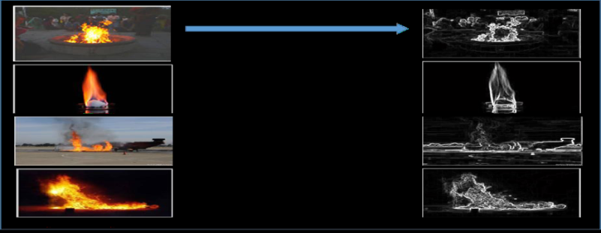
Fig 5: Show the results from the 2nd technique (Poobalan et al., 2015).
Following through image pre-processing step, here the video will be into format readable using MATLAB Software as sown in Fig. 5. Also few conversion processes was completed such as converted to grayscale to get the pixel value of each colour component. Every image has their own colour arrays which is the combination of three colours which is consist of red, green and blue (RGB). The RGB images were converted into grayscale which is in MATLAB known as rgb2gray function (18).
Smoke detection techniques:
Smoke is the early sign of most of the fires. Smoke detection is an important and necessary for the monitoring air pollution; and their effects on human health as well as on nature. Therefore it is essential to use good smoke detection method.
Additionally, these systems only work when present in very close proximity of the fire. With the use of video smoke detectors, these problems can be solved. Therefore video smoke detection is the most effective method and used in large areas such as forest fires and petrochemical refineries.
Lee et al. (19) proposed a smoke detection method using a spatial and the temporal analysis. The algorithm provides greater flexibility to smoke detection technique and the more the reliable to work under various conditions, which can be expressed by Flow diagram in Fig. 6.
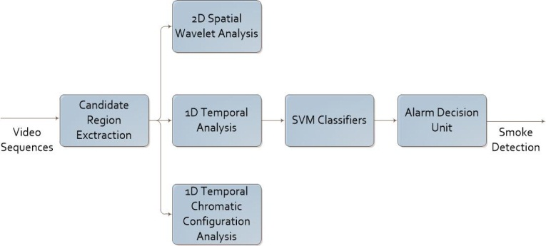
Fig. 6: System architecture of the Video Smoke detection using MATLAB/Simulink (Memane et al., 2015)
Feature extraction can be done through analysing the spatial and the temporal features of video sequences for the three major features: the gradual energy changes, edge blurring and the gradual chromatic configuration changes. This proposed algorithm were collective these three features using a temporal-based alarm decision unit and a support vector machine (SVM) techniques to obtain more the reliable experimental results. The temporal-based alarm decision unit is developed to decrease the false alarm rate and preserve a high detection rate with a short reaction of time. Support Vector Machine (SVM) algorithm is used to combine all the extracted analysed features of the fire. The SVM is trained with the classification and testing can be done fast with a C++ program which makes it suitable for many real-time applications. This proposed algorithm can be process 30.98 frames per second.
Pietro Morerio et al. (20) proposed another approach to smoke detection which is based on colour features and the dynamics analysis. In proposed system contains five main modules: (i) Change detection, (ii) The Motion detection, (iii) The Fire features extraction, (iv) The Smoke features extraction and (v) Chaotic feature extraction.
This module gives a well-known subtraction algorithm to obtained pixels which are the different than normal pixels of the background picture. A motion detection algorithm is used for the detection of smoke and the fire pixels. Pixel selection can be finished according to dynamics of the area so as to reduce false detection. Based on colour information and feature extraction module, fire and smoke pixels are divided. Separation of pixels is done with the YCbCr. Then the Chaotic analysis is performed. Optimisation of elaboration speed and lowering the amount of information can be done by wrapping segmented blob.
After Chaotic analysis, data fusion is completed to generate a new pre-alarm. The main function of this module is to reject the false alarms caused because of other fire-like moving objects. It is finished by the classifying pre-alarm rectangles with the help of a multi-layered perceptron. It’s consists of multi-layered network structure divided into input layer, some hidden layers and the output layer. This method uses three output neurons which depict the three possible states prior to the alarm. These states include no pre-alarm, the smoke type pre-alarm and the fire type pre-alarm.

- PROPOSED FIRE DETECTION METHOD:
The proposed fire detection method is a new video-based fire and the smoke detection method. It uses optical flow features for the feature vector extraction and then uses trained neural networks for the feature vector classification. The main area of this method is the optical flow vector creations that will be used to estimate the amount of motion undergone through an object while the moving from one frame to another as shown in Fig. 7.
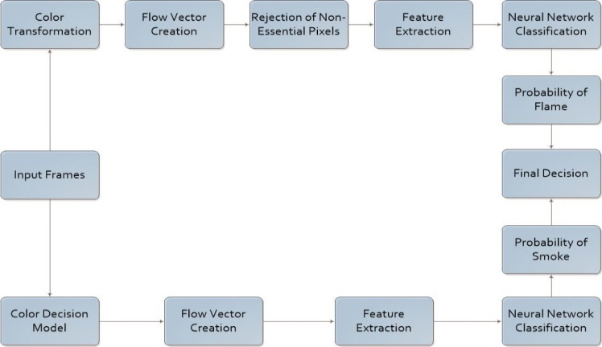
Fig 7: Block Diagram of proposed System (Memane et al., 2015)
The proposed system composed of following three steps (21):
Pre-processing is involved with the colour transformation and that the converts the input video into sequences of frames which is the suitable for processing.
Feature extraction using the optical flow estimators i.e. the Optical Mass Transport and the Non-Smooth Data; that have been designed for detecting smoke and fire. From optical mass transport essential pixels features are the extracted that are OMT transport energy and source matching, from Non-Smooth Data two essential pixels features are the extracted that are NSD flow magnitude and the directional variance.Classification to detect the flame region in the video frame with Supervised machine-learning-based on algorithm such as Neural Network. Neural networks are trained on dataset of features and ground truth; Back propagation neural network is used for the training neural network that has the highest performance in the classification. Classification algorithms use the analysed features as an input and decision at the output whether the target is present or not. In the global optimization toolbox of MATLAB was used to find the best combination of features.

- CONCLUSION
This review provides combined results at the output regarding the presence or absence of smoke and fire. The system performance can be improved with the help of optimal algorithms for detecting the motion area and for extracting the features of fire. Neural network based outputs from both, the flame and the smoke modules are combined to get a final output which were gathered in the form of an image sets. These were transformed in the set of a readable image in MATLAB software. The warning of smoke comes out if the images have smoke. While the absence of smoke will result in no smoke warning.
REFERENCES:
1. Shen C, et al. (2016) Optical flow sensor/INS/magnetometer integrated navigation system for MAV in GPS-denied environment. Journal of Sensors 2016.
2. Bruhn A, Weickert J, & Schnörr C (2005) Lucas/Kanade meets Horn/Schunck: Combining local and global optic flow methods. International Journal of Computer Vision 61(3):211-231.
3. Huda A & Taib S (2013) Suitable features selection for monitoring thermal condition of electrical equipment using infrared thermography. Infrared Physics & Technology 61:184-191.
4. Haralick RM & Shanmugam K (1973) Textural features for image classification. IEEE Transactions on systems, man, and cybernetics 3(6):610-621.
5. Kim J-H & Lattimer BY (2015) Real-time probabilistic classification of fire and smoke using thermal imagery for intelligent firefighting robot. Fire Safety Journal 72:40-49.
6. Petrov K (2012) Determining the best location of smoke sensor in office room.
7. Çelik T, Özkaramanlı H, & Demirel H (2007) Fire and smoke detection without sensors: image processing based approach. Signal Processing Conference, 2007 15th European, (IEEE), pp 1794-1798.
8. Jackson M & Robins I (1994) Gas sensing for fire detection: Measurements of CO, CO2, H2, O2, and smoke density in European standard fire tests. Fire Safety Journal 22(2):181-205.
9. Starr JW & Lattimer B (2014) Evaluation of navigation sensors in fire smoke environments. Fire Technology 50(6):1459-1481.
10. Daley WR, Smith A, Paz-Argandona E, Malilay J, & McGeehin M (2000) An outbreak of carbon monoxide poisoning after a major ice storm in Maine. The Journal of emergency medicine 18(1):87-93.
11. Dimitropoulos K, Barmpoutis P, & Grammalidis N (2016) Higher Order Linear Dynamical Systems for Smoke Detection in Video Surveillance Applications. IEEE Transactions on Circuits and Systems for Video Technology.
12. Bosch I, Serrano A, & Vergara L (2013) Multisensor network system for wildfire detection using infrared image processing. The Scientific World Journal 2013.
13. Celik T, Demirel H, Ozkaramanli H, & Uyguroglu M (2006) Fire detection in video sequences using statistical color model. Acoustics, Speech and Signal Processing, 2006. ICASSP 2006 Proceedings. 2006 IEEE International Conference on, (IEEE), pp II-II.
14. Phillips Iii W, Shah M, & da Vitoria Lobo N (2002) Flame recognition in video. Pattern recognition letters 23(1):319-327.
15. Prakash RO & Saravanan C (2016) Autonomous robust helipad detection algorithm using computer vision. Electrical, Electronics, and Optimization Techniques (ICEEOT), International Conference on, (IEEE), pp 2599-2604.
16. Chandra DS (2002) Digital image watermarking using singular value decomposition. Circuits and Systems, 2002. MWSCAS-2002. The 2002 45th Midwest Symposium on, (IEEE), pp III-III.
17. Celik T, Ozkaramanlt H, & Demirel H (2007) Fire pixel classification using fuzzy logic and statistical color model. Acoustics, Speech and Signal Processing, 2007. ICASSP 2007. IEEE International Conference on, (IEEE), pp I-1205-I-1208.
18. Poobalan K & Liew S-C (2015) Fire detection algorithm using image processing techniques. Proceedings of the 3rd International Conference on Artificial Intelligence and Computer Science (AICS2015), pp 160-168.
19. Lee C-Y, Lin C-T, Hong C-T, & Su M-T (2012) Smoke detection using spatial and temporal analyses. International Journal of Innovative Computing, Information and Control 8(7):4749-4770.
20. Morerio P, Marcenaro L, Regazzoni CS, & Gera G (2012) Early fire and smoke detection based on colour features and motion analysis. Image Processing (ICIP), 2012 19th IEEE International Conference on, (IEEE), pp 1041-1044.
21. Mueller M, Karasev P, Kolesov I, & Tannenbaum A (2013) Optical flow estimation for flame detection in videos. IEEE Transactions on image processing 22(7):2786-2797.
AUTHORS PROFILE

Hafiz Suliman Munawar received his B.Sc Engineering degree in 2014 from UET Taxila, Pakistan. Currently he is an MS research student at Research Center for Modelling
and Simulation, National University of Sciences and Technology (NUST), Pakistan. He has a competent interest in multidisciplinary studies.


Usama Khalid is working as a Research Assistant in Telesehat Pvt. Ltd. Pakistan and received his BS (Software Engineering) degree from COMSATS Institute of Information Technology, Pakistan in 2016. He has been working on TeleDiagnosis to optimize its performance.


Dr. Adnan Maqsood is working as Assistant Professor at Research Center for Modeling and Simulation, National University of Sciences and Technology (NUST), Pakistan, since 2012. He received his Bachelor degree in Aerospace Engineering from NUST, Pakistan in 2005 and PhD from Nanyang Technological University (NTU)

